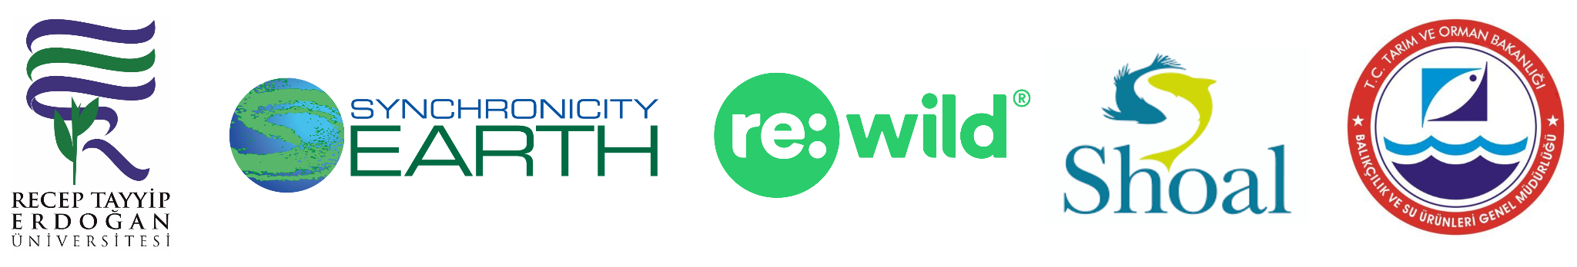
Rediscovery of lost leopard-spotted fish in Türkiye spurs hope in the midst of global freshwater fish decline
Turkish ichthyologists mobilize to protect second species found on Re:wild and SHOAL’s list of most wanted lost fishes

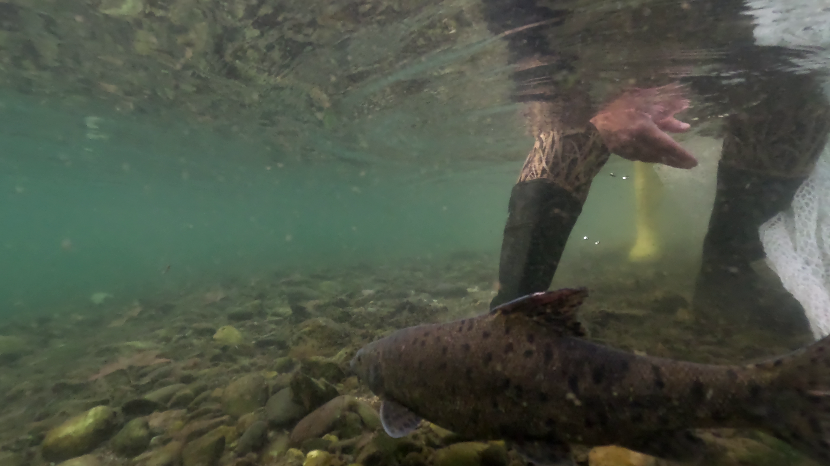

For immediate release
January 8, 2024
Download images

On the heels of the news that 25% of freshwater fish are at risk of extinction, a team of ichthyologists in Türkiye (Turkey) has rediscovered hope in the shape of a carp-like, spotted fish—the leopard barbel (Luciobarbus subquincunciatus)—in the Turkish section of the Tigris River. The species, which was last scientifically documented in 2011, is the second on Re:wild and SHOAL’s most wanted lost fishes list to be rediscovered. The first, the Batman River loach, was found by the same intrepid team in Southeastern Türkiye in late 2021.

“There is nothing quite like the feeling of finding that a species that has been pushed to the brink of extinction is still hanging on, despite the odds,” said Cüneyt Kaya, associate professor at Recep Tayyip Erdogan University and member of the expedition team. “It is even more thrilling than discovering a new species because it means that we can give a rare species a second chance. With both the Batman River loach and now the leopard barbel, we have an obligation to mobilize conservation efforts to ensure neither becomes lost again.”

The leopard barbel was once abundant, ranging from Eastern Türkiye, Eastern Syria, Iran and Iraq in the Tigris-Euphrates river system. Over the last three decades, however, fishing, pollution, habitat destruction and dam construction have pushed the species to the edge of extinction. Anecdotal evidence from local fishers suggested that the fish may still be out there, so Kaya and Münevver Oral, an assistant professor at Recep Tayyip Erdogan University, enlisted their help, in addition to working with the local fisheries aquaculture department.

The team started by looking at the scientific literature about where the species had been previously found. However, those data were collected before nine dams were built in the Turkish portion of the Tigris River. Dams alter water flow regimes, and cold water that accumulates at the bottom of reservoirs is sometimes released downstream. The release of cold water drives many freshwater fish toward warmer waters, so the team had to adjust its strategy to look further downstream from the dams.

Just days after the second of two expeditions, Kaya and Oral got the video call they had hoped for from local fisherman Mehmet Ülkü: he had caught a 20-inch (50 centimeter), 4.4-pound (2-kilogram) fish with conspicuous black spots and the telltale fleshy filament that dangles from the mouths of this type of freshwater fish.

Ülkü kept the fish alive in a tank with a constant oxygen supply overnight, while Kaya took a direct flight to Van city, then drove nearly six hours to Cizre, where the species was found. Oral drove more than 11 hours through the night to see—and help release—the fish. By the time they arrived, Ülkü had caught a second leopard barbel safely in his nets.

“We dropped everything and would have gone to the ends of the Earth to see this fish, this legend, alive in the wild,” Oral said. “I have never seen a fish as beautiful as this. It was the realization not only of our dream to find this lost species, but of the hope that not all is lost—we still have a chance to protect the leopard barbel and all of the other incredible freshwater species it shares its home with.”

After Kaya and Oral took photos and measured the size and shape of the two fish, they were joined by the local Cizre fisheries aquaculture department to safely release the fish, which they described as a joyous event.

“We all have a role to play in protecting our incredible natural heritage and I am proud to have used my skills to help rediscover the leopard barbel,” Ülkü said. “Safeguarding this species into the future is going to require educating other fishers and continuing to bring together scientific knowledge and local expertise.”

Kaya and Oral are planning to conduct a series of seminars for fishers and teachers to help build pride in their riverways and wildlife, using the rediscovery as a case study to protect the Tigris River and its rich biodiversity. They are also hoping to get a better understanding of how many leopard barbel might still exist and where they are still found across their historic range.

In November 2023, the International Union of Conservation of Nature released an updated assessment of freshwater fish across the planet, finding that dams and water extraction are putting 45% of all threatened freshwater fish at risk of extinction. Not only have several dams built in the Turkish portion of the Tigris River impacted the leopard barbel, but a new dam is under construction in Cizre, very close to where the two leopard barbels were found.

“Freshwater ecosystems play a tremendous role in maintaining the overall health of our planet,” said Harmony Patricio, freshwater fish conservation program manager for Re:wild and SHOAL. “Addressing threats and safeguarding the biodiversity that maintains these ecosystems is critical to solving the climate and biodiversity loss crises, and essential for human wellbeing. We hope the rediscovery of the leopard barbel will serve as an inspiring catalyst for future freshwater biodiversity conservation efforts in this region.”

The Search for Lost Fishes is the freshwater-fish focused branch of Re:wild’s Search for Lost Species program. Re:wild and SHOAL—which is a program of Re:wild and Synchronicity Earth—launched the Search for Lost Fishes in 2021 to encourage individuals and organizations to look for freshwater fish species that have not been scientifically documented in at least 10 years so that conservation programs can be put in place to bring them back from the brink of extinction. In collaboration with Re:wild and the IUCN-SSC Freshwater Fish Specialist Group, SHOAL has compiled a list of more than 300 fish species that are currently lost to science.

Additional quotes

Christina Biggs, Re:wild lost species officer
“For the Search for Lost Species program to be successful in preventing extinctions, we must support in-country scientists, experts in their fields, like Münevver & Cüneyt. Their skill and dedication, the understanding of the value of Türkiye’s biodiversity, is exemplary. We hope that it stands as a model for other partners and ignites them to become involved in searches for lost species in their own regions.”

Mike Baltzar, executive director of SHOAL
“The recent IUCN Red List announcement that 25% of freshwater fish are at risk of extinction highlights the pressing need for urgent, impactful conservation work. SHOAL exists to address that challenge and we’re thrilled that Münevver and Cüneyt – stars of the Batman River loach rediscovery – have taken the initiative and dedication to find a second Lost Fish! Positive news stories like this are rare in the conservation world, and can do an incredible job of engaging new audiences in conservation. Congratulations to Münevver and Cüneyt on their success.”

Julie Thomas, head of conservation programmes at Synchronicity Earth
"It is fantastic that Münevver and Cüneyt have rediscovered this beautiful fish that has been 'lost' for more than 12 years. The Search for Lost Fishes programme was established to help give species like this a better shot at survival – now that the leopard barbel has been found, conservation can be established to ensure it is given the chance to thrive."

# # #
Photo: The leopard barbel has been lost to science since 2011. (Photo by Metin Yoksu)
Download images
Re:wild
Re:wild protects and restores the wild. We have a singular and powerful focus: the wild as the most effective solution to the interconnected climate, biodiversity and human wellbeing crises. Founded by a group of renowned conservation scientists together with Leonardo DiCaprio, Re:wild is a force multiplier that brings together Indigenous peoples, local communities, influential leaders, nongovernmental organizations, governments, companies and the public to protect and rewild at the scale and speed we need. Learn more at rewild.org.

SHOAL
SHOAL is the global collaborative initiative to halt the extinction and recover populations of the most threatened freshwater species in the wild. Freshwater species are going extinct faster than their marine or terrestrial cousins, and one in three of those alive today could soon disappear, never to return. There is an urgent need for determined action, and SHOAL is building a strong community of partners that work together to give critical attention, escalate support, and accelerate and intensify the action that is required to stem the tide of extinction and recover endangered species populations throughout the Earth’s freshwaters.
Join The Shoal at shoalconservation.org.

Synchronicity Earth
Synchronicity Earth is a UK-based conservation charity that acts to address overlooked and underfunded conservation challenges for globally threatened species and ecosystems.

Contact
Michael Edmondstone
SHOAL
m.edmondstone@shoal.org.uk
+44 7411 940035

Lindsay Renick Mayer
Re:wild
lrenickmayer@rewild.org
+1 512-686-6225

